{Course: Keep My Child Safe and Healthy}

{Lesson: Teaching Safe Touch (Age 2-5/M & F) video title:safe_touch_2to5_yc - make duplicate one m one f}
Script | On Slide Text | Animation Notes
Molo, ubuyile kwi-ParentText, kwakuhle!  Esi sifundo simalunga nokugcina umntwana wakho ekhuselekile kwaye esempilweni. Namhlanje, siza kuthetha malunga nokufundisa umntwana wakho ngendlela ekhuselekile kunye nengakhuselekanga yokubanjwa.  Nazi iingcebiso eziluncedo ezine ukukukhokhela ekufundiseni umntwana wakho malunga nokubanjwa okukhuselekileyo nokungakhuselekanga kunye nokuba enze ntoni ukuba uziva engakhululekanga xa kukho umntu ombambayo.  Masifunde ngakumbi kunye! | Fundisa Ukubamba Okukhuselekileyo
Okokuqala, funda ngamalungu angasese.  Fundisa umntwana wakho ukuba amalungu omzimba wakhe angena ngaphantsi kwempahla yakhe yangaphantsi okanye kwimpahla yokuqubha ngamalungu angasese. Akulunganga ukuba abanye abantu babambe okanye bajonge amalungu abo angasese  [pause]  Akulunganga nokuba umntu acele umntwana wakho ukuba abambe okanye ajonge amalungu angasese womnye umntu.  [pause]  Okwesibini, fundisa umntwana wakho ukuba kulungile ukuthi hayi.  Xelela umntwana wakho ukuba usoloko evumelekile ukuthi hayi emntwini ombambayo, nokuba lusapho okanye abahlobo. Oku kuyinyaniso, nakwizinto ezifana nokuwola! Oku kufundisa umntwana wakho ukuba esoloko elawula ukuba ngubani na amvumelayo ukuba ambambe ukuze akwazi ukwenza ukhetho olukhuselekileyo kubo bonke ubomi bakhe, kuyo nayiphi na imeko. Unokuziqhelanisa nokuthi "Hayi, nceda ungayenzi loo nto", "Hayi! Yeka!" kunye nomntwana wakho ukuze akwazi ukuzithethela xa kunesidingo.  Ingcebiso elandelayo kukubaleka.  Fundisa umntwana wakho uzikhupha njani kuyo nayiphi na imeko emenza azive engakhululekanga. Abenzi bobubi badla ngokwaziwa ngumntwana kunye/okanye ngabagcini bantwana kwaye baqale badlale ngokujijisana okanye ukubamba. Oku kwenzelwa ukuba umntwana akhululeke ngokubanjwa. Xa udlala umdlalo ofana nokujijisana nomntwana wakho, ziqhelanise no "hayi" kwaye uhloniphe imida yakhe. Uba umntwana wakho uthi "hayi", yeka umdlalo ngoko nangoko.  [pause]  Oku kubaxhobisa ukuba bakwazi ukuthi “HAYI!” kwiimeko ezingakhuselekanga nangaphandle kwekhaya ngokunjalo.  Akuyi kuba lula ukuba umntwana abaleke kwiimeko ezinjalo, kodwa ukumfundisa indlela yokuhamba xa eziva engakhululekanga kuya kunceda.  [pause]  Okokugqibela, fundisa umntwana wakho ukuxelela umntu omdala.  Xelela umntwana wakho ukuba xa eziva exhalabile, engakhululekanga, okanye engakhuselekanga nangaye nabani na ombambayo, kufuneka akuxelele wena okanye umntu omdala amthembileyo. Hlala umkholelwa umntwana wakho xa ekuxelela ngomntu ombambayo ngendlela engakhuselekanga.  [pause]  Ukuba umntwana wakho ukuxelela ngento eyenzekileyo, mphulaphule kwaye umxelele ukuba wenze kakuhle akuxelele. Emva koko, thatha amanyathelo wokumkhusela. Mkholelwe rhoqo umntwana wakho, kwaye ungamshiyi yedwa nomntu aziva engakhuselekanga naye. | FUNDA MALUNGA NAMALUNGU ANGASESE  U"HAYI" UVUMELEKILE!  BALEKA  XELELA UMNTU OMDALA | Animate words to text
Khumbula, ukuse ufundise umntwana wakho malunga nokubanjwa okukhuselekileyo nokungakhuselekanga, landela la macebiso mane - funda ngamalungu angasese, ukuthi "hayi" kulungile, ukubaleka njani, kwaye uxelele umntu omdala.  Umsebenzi wakho wasekhaya kukuba nencoko nomntwana wakho malunga nokubanjwa okukhuselekileyo nokungakhuselekanga. Mncede aziqhelanise nokuthi, “Hayi, sukuyenza loo nto!” okanye “Hayi! Yeka!" kwaye umkhumbuze ukuba axelele umntu omdala ukuba kuyenzeka.  Ungakwazi ukwenza oku kunye nomntwana wakho namhlanje? | Ukufundisa Ukubamba Okukhuselekileyo  FUNDA MALUNGA NAMALUNGU ANGASESE  U"HAYI" UVUMELEKILE!  BALEKA  XELELA UMNTU OMDALA  Umsebenzi Wasekhaya:  Yiba nencoko malunga nokubanjwa okukhuselekileyo nokungakhuselekanga.

{Lesson: Teaching Safe Touch (Age 6-9)}
Script | On Slide Text | Animation Notes
Molo, ubuyile kwi-ParentText, kwakuhle!  Esi sifundo simalunga nokugcina umntwana wakho ekhuselekile kwaye esempilweni. Namhlanje, siza kuthetha malunga nokufundisa umntwana wakho ngendlela ekhuselekile kunye nengakhuselekanga yokubanjwa.  Nazi iingcebiso ezintlanu ukukunceda ufundise umntwana wakho malunga nokubanjwa okukhuselekileyo kunye nento amakayenze xa eziva engakhuselekanga xa kukho umntu omchukumisayo.  Ukulungele ukufunda ngakumbi? | Fundisa Ukubamba Okukhuselekileyo
Ingcebiso yokuqala, nyaniseka.  Thetha nomntwana wakho malunga nendlela yokubiza ilungu ngalinye lomzimba wakhe. Ukuba umntwana wakho uyayazi indlela umzimba wakhe osebenza ngayo kunye nalapho abantu befanelekile okanye bengafanelekanga ukuba bambambe khona, unokwenza ukhetho olukhuselekileyo kubo bonke ubomi bakhe.  Phendula nawuphi na umbuzo umntwana wakho awubuzayo ngokunyanisekileyo. Le mibuzo isenokuba ngalo naliphi na ilungu lomzimba wakhe okanye elesinye isini - nkqu namalungu angasese!  Oku kubafundisa ukuba kukhuselekile ukubuza ngomzimba, okuthetha ukuba bazakufunda ngakumbi kwaye bahlale bekhuselekile.  Ukufundisa umntwana wakho ngomzimba wakhe wonke, nokuba usemncinci, kuthetha ukuba uya kuyazi indlela yokuthetha xa kukho nantoni na eyenzekayo avakalelwa ukuba ayikhuselekanga. | NYANISEKA ngendlela yokubiza amalungu omzimba ngamagama kunye nendlela esebenza ngayo imizimba
Ingcebiso yesibini kukufundisa umntwana wakho ukuba kuvumelekile ukuthi hayi.  Xelela umntwana wakho ukuba usoloko evumelekile ukuba athi hayi kumntu ombambayo nokuba lusapho okanye abahlobo. Oku kuyinyaniso nakwizinto ezifana nokuwola!  Oku kufundisa umntwana wakho ukuba usoloko elawula ukuba ngubani na amvumelayo ukuba ambambe ukuze akwazi ukwenza ukhetho olukhuselekileyo kubo bonke ubomi bakhe, kuyo nayiphi na imeko.  Unokuziqhelanisa nokuthi "Hayi, nceda ungayenzi loo nto", "Hayi! Yeka!" kunye nomntwana wakho ukuze akwazi ukuzithethela xa kunesidingo. | U"HAYI" UVUMELEKILE!  ziqhelanise nokuthi "Hayi, nceda ungayenzi loo nto" kwaye "Hayi! Yeka!"
Ingcebiso yesithathu kukubaleka.  Fundisa umntwana wakho indlela yokuzikhupha kuyo nayiphi na imeko apho aziva engakhululekanga. Kwiimeko ezininzi, abenzi bobubi ayingobantu bangaziwayo ngumntwana. Abenzi bobubi badla ngokwaziwa ngumntwana kunye/okanye ngabagcini bantwana kwaye baqale badlale ngokujijisana okanye ukubamba. Oku kwenzelwa ukuba umntwana akhululeke ngokubanjwa.  Xa udlala umdlalo ofana nokujijisana nomntwana wakho, ziqhelanise no "hayi" kwaye uhloniphe imida yakhe. Uba umntwana wakho uthi "hayi", yeka umdlalo ngoko nangoko.  Oku kubaxhobisa ukuba bakwazi ukuthi "HAYI" kwiimeko ezingakhuselekanga nangaphandle kwekhaya ngokunjalo. Akuyi kuba lula ukuba umntwana abaleke kwiimeko ezinjalo, kodwa ukumfundisa indlela yokuhamba xa eziva engakhululekanga kuya kunceda. | HAMBELA KUDE kwiimeko ezenza umntwana wakho azive engakhululekanga
Okulandelayo, xelela umntu omdala.  Xelela umntwana wakho ukuba xa kukho umntu omenza azive exhalabile, engakhululekanga, okanye engakhuselekanga omphathayo, kufuneka akuxelele okanye umntu omdala amthembileyo.  [pause]  Ukuba umntwana wakho ukuxelela ngento eyenzekileyo, mphulaphule kwaye umxelele ukuba wenze kakuhle akuxelele. Emva koko, thatha amanyathelo wokumkhusela. Mkholelwe rhoqo umntwana wakho, kwaye ungamshiyi yedwa nomntu aziva engakhuselekanga naye. | XELELA UMNTU OMDALA ngayo nangantoni na ekwenza uzive ungakhululekanga okanye ungakhuselekanga
Khumbula, ukufundisa umntwana wakho malunga nokubanjwa okukhuselekileyo nokungakhuselekanga, landela la macebiso amahlanu - nyaniseka, ukuthi "hayi" kulungile, indlela yokubaleka, xelela umntu omdala, kwaye ufumane uncedo.  Umsebenzi wakho wasekhaya namhlanje kukuba nencoko nomntwana wakho malunga nokubanjwa okukhuselekileyo nokungakhuselekanga. Mncede aziqhelanise nokuthi, “Hayi, sukuyenza loo nto!” kwaye umkhumbuze ukuba axelele umntu omdala ukuba kuyenzeka.  Ungakwazi ukwenza oku nomntwana wakho namhlanje? | Fundisa Ukubamba Okukhuselekileyo  NYANISEKA  U"HAYI" UVUMELEKILE!  BALEKA  XELELA UMNTU OMDALA  PHENDULA  UMSEBENZI WASEKHAYA  Yiba nencoko malunga nokubanjwa okukhuselekileyo nokungakhuselekanga.

{Lesson: Community Safety (2-4)}
Script | On Slide Text | Animation Notes
Molo, kwakuhle ukukubona kwakhona kwi ParentText!  Esi sifundo simalunga nokufunda indlela yokugcina umntwana wakho ekhuselekile kwindawo ohlala kuyo.  Into onokuyenza ukuze ugcine umntwana wakho ekhuselekile kukuthetha naye malunga neendawo ezikhuselekileyo anokuya kuzo nezingakhuselekanga, uze umfundise indlela yokulumka xa edibana nabantu angabaziyo.  Nanga amanyathelo amane anokukunceda kule ncoko:  Zoba  [pause]  thetha,  [pause]  xoxa,  [pause] kwaye uziqhelanise.  Masifunde ngakumbi kunye! | Ukhuseleko Ekuhlaleni  ZOBA  THETHA  XOXA  ziqhelanise
Inyathelo lokuqala KUKUZOBA.  Zoba imephu yendawo ohlala kuyo, kunye nomntwana wakho. Bandakanya zonke iindawo eziphambili kwindawo ohlala kuyo kwimephu, njengendlu yakho, izitalato ezikwingingqi yakho, ikhritshi, kunye nezinye iindawo wena nomntwana wakho eninokuthi niye kuzo. [1]  Zoba kwaye umbonise imifanekiso yabantu obathembileyo umntwana wakho anokuya kubo xa eziva engakhuselekanga. Aba isenokuba nguwe neqabane lakho, amanye amalungu osapho, okanye ootitshala babo. | ZOBA | Begin with a blank sheet. Animate on [1]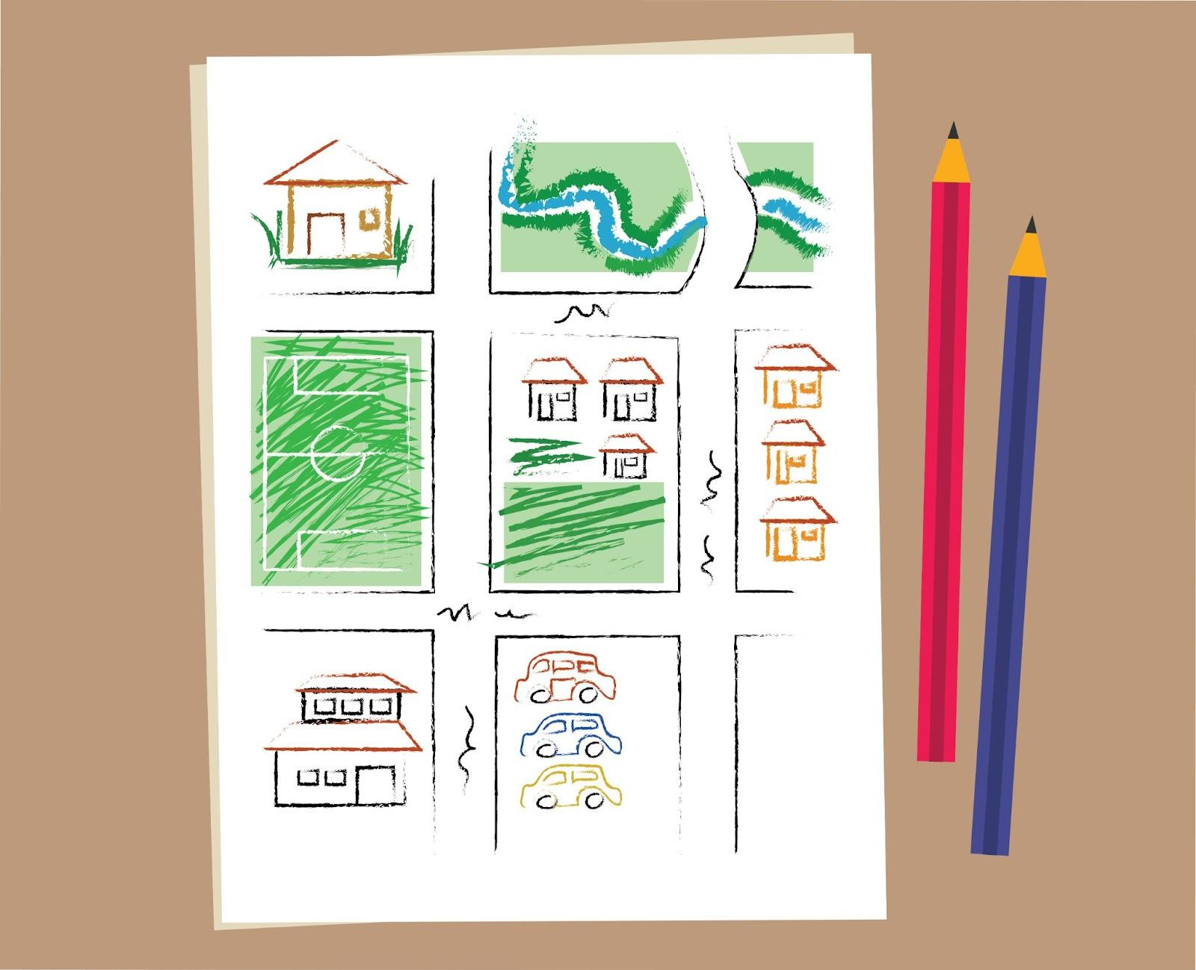
Inyathelo elilandelayo KUKUTHETHA.  Thetha ngeendawo ezikhuselekileyo nezingakhuselekanga kwimephu yakho. Umzekelo, xelela umntwana wakho ukuba isitalato asiyondawo ekhuselekileyo, nokuba into yokudlala okanye ibhola ilapho.  [1] YENZA ISANGQA kwiindawo ezikhuselekileyo ebantwaneni. NQAMLA naziphi na iindawo ezingakhuselekanga kumntwana wakho. Umzekelo, iivenkile, iirenki, okanye izakhiwo ezingaqhelekanga okanye ezingahlali bantu. | THETHA | Qala ngephepha langaphambili. Animate on [1]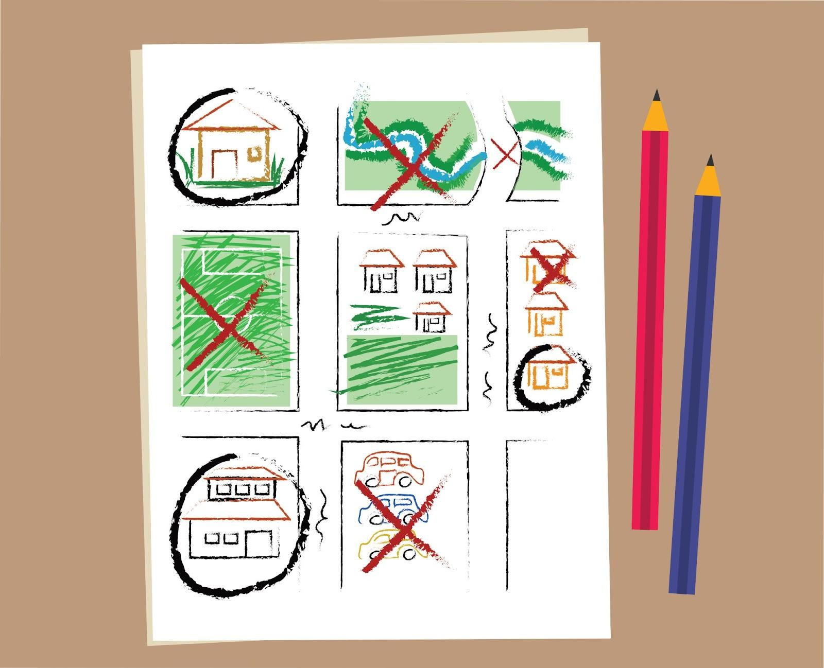
Inyathelo lesithathu KUKUXOXA. Xoxela umntwana wakho ukuba kutheni kubalulekile UKUHLALA enomntu omdala xa ephuma phandle. Qinisekisa ukuba umntwana wakho uyazi ukuba kulungile ukuhamba okanye ukubalekela ngaphakathi endlini xa umntu angamaziyo ezama ukuthetha naye okanye emcela ukuba aye ndaweni ithile. Xoxa nomntwana wakho ngeendawo ezikhuselekileyo anokuthi abalekele kuzo ukuba umntu ongamaziyo uyeza kuye - njengekhaya lakho, okanye ikhaya lommelwane.  [1] Phawula ezi ndawo ngokucacileyo ngenkwenkwezi kwimephu yakho. | XOXA | Begin with the previous sheet. Animate on [1]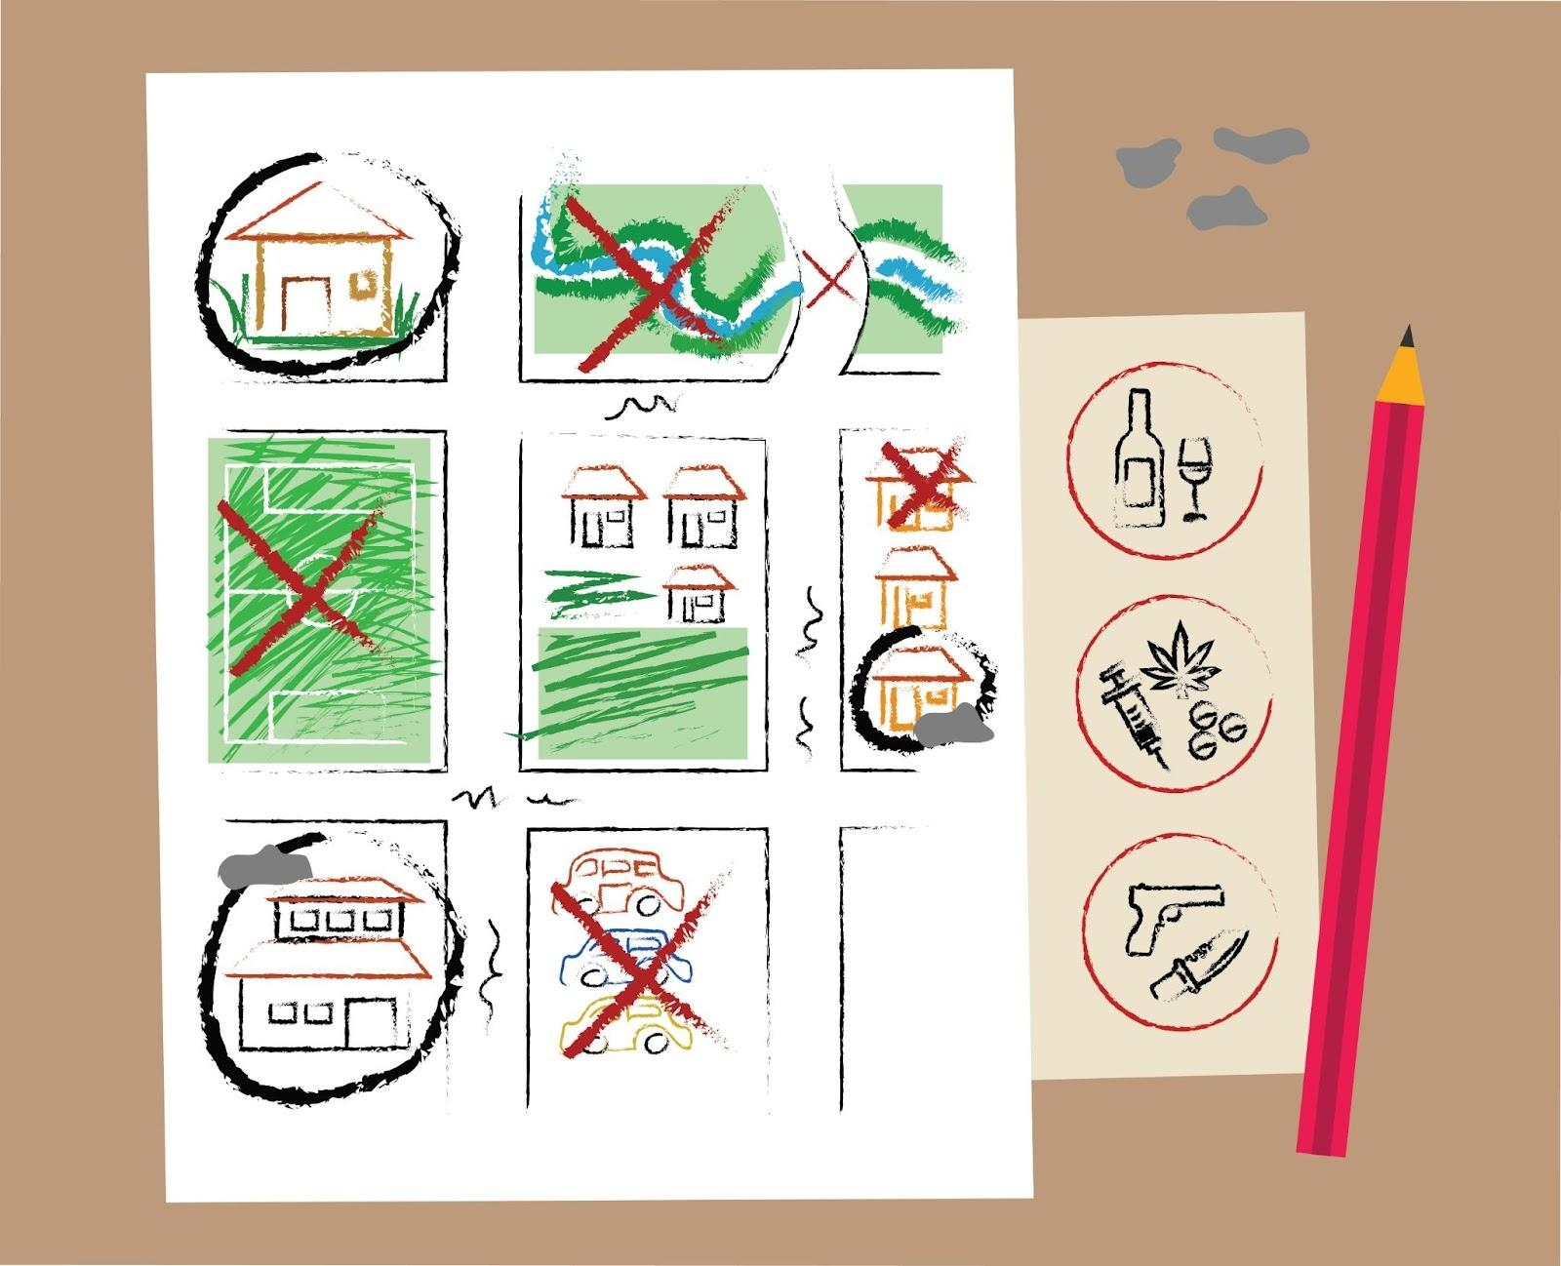
Inyathelo lokugqibela kukuziqhelanisa, ukuziqhelanisa, ukuziqhelanisa!  Linganisa wenze imizekelo apho kufika umntu angamaziyo, usebenzise izinto zokudlala okanye oonopopi. Buza umntwana wakho ukuba ina msebenzi mni lento yokudlala. Abantwana bakufumanisa kungoyikisi kangako ukwenza ngathi omnye umntu usengozini.  Khumbula ukumncoma umntwana wakho xa ekhetha impendulo echanekileyo, njengokubaleka, ukukhwaza ecela uncedo, okanye ukufumana umntu omdala amthembileyo. | ZIQHELANISE  Dlala umdlalo usebenzisa izinto zokudlala okanye oonopopi  Khumbula ukuncoma
Ukuthetha ngeemeko ezingakhuselekanga nomntwana wakho kunokwenza azive engakhululekanga, kodwa kubalulekile. Xa abantwana besazi ukuba benze ntoni kwimeko eyingozi, bakhuseleka ngakumbi.  Umsebenzi wakho wasekhaya kukuba nencoko nomntwana wakho malunga nokuba zeziphi iindawo ezikhuselekileyo okanye ezingakhuselekanga ebantwaneni kwindawo ohlala kuyo. Ingaba unalo ixesha lokuyenza namhlanje? | Ukhuseleko Ekuhlaleni  UMSEBENZI WASEKHAYA  Thetha nomntwana wakho malunga neendawo ezikhuselekileyo nezingakhuselekanga kwindawo ohlala kuyo

{Lesson: Community Safety (5-9)}
Script | On Slide Text | Animation Notes
Molo! Esi sifundo simalunga nokugcina umntwana wakho ekhuselekile kwaye namhlanje sifunda ngokhuseleko ekuhlaleni.  Into onokuyenza ukuze ugcine umntwana wakho ekhuselekile kukuthetha naye malunga nokuba zeziphi iindawo ezikhuselekileyo anokuya kuzo nezingekhuselekanga, uze umfundise indlela yokulumka xa edibana nabantu angabaziyo.  Nanga amanyathelo amane onokukunceda kule ncoko:  Zoba  [pause]  thetha,  [pause]  xoxa,  [pause] kwaye ziqhelanise.  Masifunde ngakumbi kunye! | Ukhuseleko Ekuhlaleni  ZOBA  THETHA  XOXA  ziqhelanise
Inyathelo lokuqala KUKUZOBA.  Zoba imephu yendawo ohlala kuyo, kunye nomntwana wakho. Bandakanya zonke iindawo eziphambili kwindawo ohlala kuyo kwimephu, njengendlu yakho, izitalato ezikwingingqi yakho, isikolo, iivenkile kunye nezinye iindawo wena nomntwana wakho eninokuthi niye kuzo. [1]  Zoba kwaye umbonise imifanekiso yabantu obathembileyo umntwana wakho anokuya kubo xa eziva engakhuselekanga. Isenokuba nguwe neqabane lakho, amanye amalungu osapho, okanye abafundisi-ntsapho bakhe. | ZOBA | Begin with a blank sheet. Animate on [1]
Inyathelo elilandelayo KUKUTHETHA.  Thetha ngeendawo ezikwimephu yakho kwaye uthathe isigqibo sokuba zikhuselekile na okanye hayi.  Qinisekisa ukuba uyamphulaphula umntwana wakho. Kubalulekile ukuqonda ukuba kutheni becinga ukuba indawo ikhuselekile okanye ayikhuselekanga.  [1] YENZA ISANGQA kwiindawo ezikhuselekileyo ebantwaneni. NQAMLA naziphi na iindawo ezingakhuselekanga kumntwana wakho. Umzekelo, iindawo ezisakhiwayo, iindawo zokupaka iimoto, okanye izakhiwo ezingaqhelekanga. | THETHA | Begin with the previous sheet. Animate on [1]
Inyathelo lesithathu KUKUXOXA.  Ngamanye amaxesha, sizifumana sisengxakini. Qinisekisa ukuba umntwana wakho uyazi ukuba kulungile ukuhamba okanye ukubalekela ngaphakathi endlini xa umntu angamaziyo ezama ukuthetha naye okanye emcela ukuba aye ndaweni ithile. Xoxani wena nomntwana wakho ngokuba ninokuyifumana phi inkxaso xa kukho ingxaki. Ezi ndawo zinokuquka ikhaya, isikolo, isikhululo samapolisa okanye ikliniki.  [1] Phawula ezi ndawo ngokucacileyo ngenkwenkwezi kwimephu yakho. | XOXA | Begin with the previous sheet. Animate on [1]
Okokugqibela, ziqhelanise! ziqhelanise! ziqhelanise!  Linganisa iimeko apho umntu ongamaziyo esiza esebenzisa izinto zokudlala okanye oonopopi. Buza umntwana wakho ukuba ina msebenzi mni lento yokudlala. Abantwana bakufumanisa kungoyikisi kangako ukwenza ngathi omnye umntu usengozini. Khumbula ukumncoma umntwana wakho xa ekhetha impendulo echanekileyo, njengokubaleka, ukukhwaza ecela uncedo, okanye ukufumana umntu omdala amthembileyo. | ZIQHELANISE  Dlala umdlalo usebenzisa izinto zokudlala okanye oonopopi  Khumbula ukuncoma
Ukuthetha ngeemeko ezingakhuselekanga nomntwana wakho kunokwenza azive engakhululekanga, kodwa kubalulekile. Xa abantwana besazi ukuba benze ntoni kwimeko eyingozi, bakhuseleka ngakumbi.  Umsebenzi wakho wasekhaya kukuba nencoko nomntwana wakho malunga nokuba zeziphi iindawo ezikhuselekileyo okanye ezingakhuselekanga ebantwaneni kwindawo ohlala kuyo. Nika umntwana wakho ithuba lokuba abelane ngeengcinga zakhe naye. Basenokucinga ukuba indawo ethile ayikhuselekanga obucinga ukuba ikhuselekile. Bavumele bacacise izizathu zabo. Ingaba unalo ixesha lokuyenza namhlanje? | Ukhuseleko Ekuhlaleni  UMSEBENZI WASEKHAYA  Yibe nengxoxo nomntwana wakho malunga neendawo ezikhuselekileyo nezingakhuselekanga kwindawo ohlala kuyo

{Lesson: Responding to Crises (2-6)}
Script | On Slide Text | Animation Notes
Molo! Kwesi sifundo besifunda ngokugcina umntwana wakho ekhuselekile. Kwesi sifundo sifunda ngendlela yokusabela kumntwana wakho xa usengxakini.  Kubalulekile ukuba umxhase umntwana wakho xa ehlangabezana nemeko enzima. Xa unceda umntwana wakho kwingxaki, khumbula ezizinto zine: [pause] phefumla, [pause] mamela, [pause] sabela, [pause] kwaye thuthuzela.  Masifunde ngakumbi ngala manyathelo kunye. | Phendula kwiiNgxaki  PHEFUMLA  MAMELA  SABELA  THUTHUZELA
Okokuqala, phefumla. Hlala uzolile. Zibuze, "Umntwana wam udinga ntoni ngoku?"  Okulandelayo, mamela. Buza umntwana wakho ukuba kuqhubeka ntoni. Vumela umntwana wakho abelane nawe ngoko akudingayo. Ngamanye amaxesha, umntwana wakho unokukhululeka ukwabelana ngokuzoba okanye ukusebenzisa izinto zokudlala kunye noonopopi ukukuxelela into ebacaphukisileyo. Qaphela indlela abavakalelwa ngayo kwaye ubaxelele into oyiqaphelayo ukuze bazive beviwe. Xelela umntwana wakho ukuba ukhona kubo kwaye uyamthanda. Khumbula, amantombazana kunye namakhwenkwe banokujongana namaxesha anzima kunye neemeko ezinzima. Bajonge bobabini.  Inyathelo lesithathu kukusabela. Yintoni enokunceda oku kuqhubekayo? Kusenokufuneka umncede umntwana wakho athethe ngeemvakalelo zakhe. Khumbula, okwangoku, umntwana wakho ufuna ukuba ube kunye naye ngothando kwaye wamkele iimvakalelo zakhe. Kusenokufuneka uthethe ngezinto onokuzenza wena okanye umntwana wakho ukuze uncede ngento eyenzekileyo. Khumbula, ungasoloko ubhala [1]NCEDA kwiParentText kwaye ufumane ulwazi malunga nezixhobo kwindawo ohlala kuyo apho unokufumana uncedo ukuba uyaludinga.  [2]  Ekugqibeleni, thuthuzela umntwana wakho. Yiba khona kumntwana wakho. Kusenokuba nzima ukubona umntwana wakho ekhathazekile okanye edidekile, kodwa zininzi izinto onokuzenza ukuze umxhase. Kufuneka umamkele uze umthuthuzele xa kukho izinto ezinzima eziqhubekayo. Kulamaxesha, ukugcina ucwangciso olungaguquguqukiyo kunokuba luncedo ngokukhethekileyo. Iinkqubo eziqhelekileyo zinokunika imvakalelo yokhuseleko kunye nokuqhelekileyo, ukunceda umntwana wakho azive ekhuselekile kwakhona. Khumbuza umntwana wakho kwakhona ukuba uyamthanda, kwaye umbulele ngokwabelana nawe. | PHEFUMLA  Hlala uzolile  MAMELA  Mamela umntwana wakho kwaye uqaphele ukuba baziva njani  SABELA  Yintoni enokunceda umntwana wakho ngoku?  [1] NCEDA  THUTHUZELA  Nika umntwana wakho intuthuzelo | Animate words to text  [1] Add a phone with HELP on the screen. Remove it at [2]
Kunokuba nzima ukubona umntwana wakho ecaphukile okanye edidekile, kodwa khumbula ukuba kuninzi onokukwenza ukubaxhasa ngexesha elinzima. Uyiphethe lento, ungumzali obalaseleyo!  Landela la manyathelo xa umntwana wakho esabelana ngento enzima. Ukuxhasa umntwana wakho ngexesha lobunzima kuya kumfundisa indlela yokuxhasa abanye ngamaxesha anzima.  Ngomsebenzi wakho wasekhaya, [1] fumana ixesha elizolileyo lokujonga imephu yasekuhlaleni oyenzileyo nomntwana wakho ngexesha lengcebiso yangaphambili. [2] Thetha ngeengozi ezinokubakho nezinto abanokuzenza ukuze baziphephe. [3] Xoxa ngezinto onokuzenza nomntwana wakho ukuba ziyenzeka.  Ingaba unalo ixesha lokwenza oku namhlanje? | Ukusabela Kwii-Ngxaki  PHEFUMLA  MAMELA  SABELA  THUTHUZELA  UMSEBENZI WASEKHAYA: [1] Jonga kwimephu yokhuseleko ekuhlaleni  [2] Thetha nomntwana wakho ngeengozi ezinokubakho. [3] Xoxa ngento omawuyenze xa isenzeka. | Animate sentences to script either as bullets or in paragraph form. Show map from previous activity.

{Lesson: Respond to Crises (7-9)}
Script | On Slide Text | Animation Notes
Molo! Kwesi sifundo besifunda ngokugcina umntwana wakho ekhuselekile. Kwesi sifundo sifunda ngendlela yokusabela kumntwana wakho xa usengxakini.  Kubalulekile ukuba umxhase umntwana wakho xa ehlangabezana nemeko enzima. Xa unceda umntwana wakho kwingxaki, khumbula ezizinto zine: [pause] phefumla, [pause] mamela, [pause] sabela, [pause] kwaye thuthuzela.  Masifunde ngakumbi ngala manyathelo kunye. | Phendula kwiiNgxaki  PHEFUMLA  MAMELA  SABELA  THUTHUZELA
Inyathelo lokuqala kukuphefumla. Ungafuna ukuma kancinci ukuze uzole ngaphambi kokuzibuza, ''Ingaba yintoni edingwa ngumntwana wam ngoku?''  Okulandelayo, mamela. Buza umntwana wakho ukuba kuqhubeka ntoni. Vumela umntwana wakho abelane nawe ngoko akudingayo. Ngamanye amaxesha, umntwana wakho unokukhululeka ukwabelana ngokuzoba okanye ukusebenzisa izinto zokudlala kunye noonopopi ukukuxelela into ebacaphukisileyo. Qaphela indlela abavakalelwa ngayo kwaye ubaxelele into oyiqaphelayo ukuze bazive beviwe. Xelela umntwana wakho ukuba ukhona kubo kwaye uyamthanda. Khumbula, amantombazana kunye namakhwenkwe banokujongana namaxesha anzima kunye neemeko ezinzima. Bajonge bobabini.  Inyathelo lesithathu kukusabela. Yintoni enokunceda oku kuqhubekayo? Kusenokufuneka umncede umntwana wakho athethe ngeemvakalelo zakhe. Khumbula, okwangoku, umntwana wakho ufuna ukuba ube kunye naye ngothando kwaye wamkele iimvakalelo zakhe. Kusenokufuneka uthethe ngezinto onokuzenza wena okanye umntwana wakho ukuze uncede ngento eyenzekileyo. Khumbula, ungasoloko ubhala [1]NCEDA kwiParentText kwaye ufumane ulwazi malunga nezixhobo kwindawo ohlala kuyo apho unokufumana uncedo ukuba uyaludinga.  [2]  Ekugqibeleni, thuthuzela umntwana wakho. Yiba khona kumntwana wakho. Kusenokuba nzima ukubona umntwana wakho ekhathazekile okanye edidekile, kodwa zininzi izinto onokuzenza ukuze umxhase. Kufuneka umamkele uze umthuthuzele xa kukho izinto ezinzima eziqhubekayo. Kulamaxesha, ukugcina ucwangciso olungaguquguqukiyo kunokuba luncedo ngokukhethekileyo. Iinkqubo eziqhelekileyo zinokunika imvakalelo yokhuseleko kunye nokuqhelekileyo, ukunceda umntwana wakho azive ekhuselekile kwakhona. Khumbuza umntwana wakho kwakhona ukuba uyamthanda, kwaye umbulele ngokwabelana nawe. | PHEFUMLA  Hlala uzolile  MAMELA  Mamela umntwana wakho kwaye uqaphele ukuba uziva kanjani  SABELA  Yintoni enokunceda umntwana wakho ngoku?  [1] NCEDA  THUTHUZELA  Nika umntwana wakho intuthuzelo | Animate words to text  [1] Add a phone with HELP on the screen. Remove it at [2]
Kunokuba nzima ukubona umntwana wakho ecaphukile okanye edidekile, kodwa khumbula ukuba kuninzi onokukwenza ukubaxhasa ngexesha elinzima. Uyiphethe lento, ungumzali obalaseleyo!  Landela la manyathelo xa umntwana wakho esabelana ngento enzima. Ukuxhasa umntwana wakho ngexesha lobunzima kuya kumfundisa indlela yokuxhasa abanye ngamaxesha anzima.  Ngomsebenzi wakho wasekhaya, [1] fumana ixesha elizolileyo lokujonga imephu yasekuhlaleni oyenzileyo nomntwana wakho ngexesha lengcebiso yangaphambili. [2] Thetha ngeengozi ezinokubakho nezinto abanokuzenza ukuze baziphephe. [3] Xoxa ngezinto onokuzenza nomntwana wakho ukuba ziyenzeka.  Ingaba unalo ixesha lokwenza oku namhlanje? | Ukuphendula Kwii Ngxaki  PHEFUMLA  MAMELA  SABELA  THUTHUZELA  UMSEBENZI WASEKHAYA: [1] Jonga kwimephu yokhuseleko loluntu  [2] Thetha nomntwana wakho ngeengozi ezinokubakho. [3] Xoxa ngento omawuyenze xa isenzeka. | Animate sentences to script either as bullets or in paragraph form. Show map from previous activity.

{Lesson:Knowing Basics of Online Safety}
Script | On Slide Text | Animation Notes
Molo kwakhona! Isifundo sanamhlanje simalunga nendlela yokugcina umntwana wakho ekhuselekile kwi-intanethi.  Abantwana bachitha ixesha elininzi kwi-intanethi. Ukunxibelelana kuyabanceda bahlale bekhuthazekile kwaye bafunde ngakumbi, kodwa kukwakho nemingcipheko ethile kunye neengozi. Ukugcina umntwana wakho ekhuselekile kwi-intanethi linyathelo elibalulekileyo lokumnceda abeyinxalenye yehlabathi ledijithali.  Xa kuziwa kukhuseleko lwe-intanethi, kukho iingcebiso ezine ekufuneka uzigcine engqondweni:  FUNDA,  KHUSELA,  YAKHA IMIKHWA,  kwaye YAKHA UKUTHEMBA.  Kuninzi okunokwabelwana ngako. Siza kugubungela ukhuseleko lwe-intanethi kwizifundo ezibini.  [1] Namhlanje, sijonga iingcebiso [pause] FUNDA [pause] kwaye UKUKHUSELA.  Isifundo esilandelayo siza kugubungela [pause] YAKHA IMIKHwa [pause] kwaye YAKHA UKUTHEMBA.  Masiqale. | Ukwazi iZiseko zoKhuseleko lwe-Intanethi  FUNDA  KHUSELA  YAKHA IMIKHWA  YAKHA UKUTHEMBA | Circle around 1 and 2
Okokuqala, funda ngeengozi zokuba kwi-intanethi:  UMXHOLO: Umntwana wakho angadibana nesiqulatho esiyingozi okanye umxholo ocinga ukuba awumfanelanga, njengobundlobongela, ulwimi olundlongo-ndlongo, okanye amanyala.  UQHAGAMSHELWANO: Abantu abadala banokuzenza abantwana baze bacele imifanekiso yezesondo okanye badibane nomntwana wakho ngeqonga lakwi intanethi.  INDLELA YOKUZIPHATHA: Ngamanye amaxesha, abantwana okanye abantu ongabaziyo banokuthetha okanye benze izinto ezibuhlungu kwi-intanethi. | FUNDA:  Umxholo  Uqhagamshelwano  Ukuziphatha | Animate words to text
Okulandelayo, khusela. Gcina umntwana wakho ekhuselekile kwi intanethi.  Thetha nomntwana wakho malunga nokuba zeziphi ii-apps kunye neewebhusayithi ezikhuselekileyo nezingakhuselekanga. Kubalulekile ukuxoxa kwakhona ukuba kutheni bekhuselekile okanye bengakhuselekanga.  Nceda umntwana wakho afunde ukwenza amagama ayimfihlo aqinileyo ukukhusela izixhobo zakhe.  Xelela umntwana wakho ukuba kufuneka agcine iinkcukacha zobuqu ziyimfihlo, ukuquka iifoto okanye iividiyo zakhe. Oko kungena kwi intanethi kuhlala kwi intanethi! | KHUSELA  Thetha nomntwana wakho ngee apps ezikhuselekileyo  Nceda umntwana wakho afunde ngeephasiwedi ezinamandla  Xelela umntwana wakho ukuba yintoni emayigcinwe bucala | Animate words to text
Kwiseshini elandelayo, sizakuqhubeka ngokufunda ngokhuselekon lwe-intanethi. Namhlanje, umsebenzi wakho wasekhaya kukubuza umntwana wakho ukuba benza ntoni ukuze bahlale bekhuselekile kwi-intanethi. Unokufumanisa ukuba sele becinga ngokhuseleko lwe-intanethi.  Mncome umntwana wakho ngazo naziphi na iinzame azenzayo. Ingaba ngakwazi ukuthetha nomntwana wakho namhlanje? | Yazi iZiseko zoKhuseleko lwe-Intanethi  Funda ✅  Khusela  Yakha Imikhwa  Yakha Ukuthemba  UMSEBENZI WASEKHAYA  Buza umntwana wakho ukuba benza ntoni ukuze bahlale bekhuselekile kwi-intanethi

{Lesson: Build Habits and Trust Online}
Script | On Slide Text | Animation Notes
Wamkelekile kwakhona kwi ParentText ! Esi sifundo siyaqhubeka nokufunda kwethu malunga nokugcina abantwana bethu bekhuselekile kwi-intanethi.  Ukugcina umntwana wakho ekhuselekile kwi-Intanethi linyathelo elibalulekileyo lokumnceda abe yinxalenye yehlabathi ledijithali.  Ubusele ufundile ngeendlela zokukhusela umntwana wakho kwi intanethi ngoku FUNDA kunye noku KHUSELA kwisifundo esigqithileyo.  Namhlanje, sifunda indlela yoKWAKHA IMIKHWA kunye noKWAKHA ITHEMBA.  Ingaba ukulungele ukuqala? | Yakha Imikhwa kunye ne Themba kwi Intanethi  FUNDA  KHUSELA  YAKHA IMIKHWA  YAKHA ITHEMBA | Circle number 3 and 4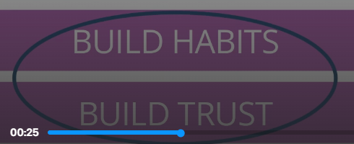
Inyathelo elilandelayo kuKWAKHA IMIKHWA. Misela imikhwa ekhuselekileyo ye-intanethi ekhaya.  Cwangcisa amaxesha okungasetyenziswa kwe fowuni kwikhaya lakho, njenga xa kutyiwa, ngexesha lomsebenzi wasekhaya wesikolo okanye ebhedini.  Misela imida yexesha umntwana wakho alichitha kwi intanethi.  Vumela umntwana wakho ukuba ancokole kwi-intanethi nabantu abasele bebazi kuphela. Bangaze babelane ngenkcukatha zabo kwi gumbi lokuncokola labucala okanye nabantu abangabaziyo.  Phambi kokuba ugcwalise iifomu ezicela iinkcukacha zakho, jonga ukuba idilesi yewebhu iqala ngo-https://. Iiwebhusayithi eziqala ngo https:// zisenokungakhuseleki. | YAKHA IMIKHWA  - Cwangcisa amaxesha okungasetyenziswa kwe fowuni ekhayeni lakho  - Jonga iidilesi ze webhu  https://  http:// | Animate to text
Kubantwana abadala, unokubanceda benze amagama ayimfihlo aqinileyo kwiiakhawunti zabo. Iipassword ezilungileyo zezi:  [pause] zinde  [pause] musa ukubandakanya iinkcukacha zobuqu ezicacileyo njengegama lakho okanye usuku lwakho lokuzalwa;  [pause] kwaye ibandakanye oonobumba abakhulu nabancinci, amanani kunye neesimboli.  Xelela umntwana wakho ukuba angacofi kwii-pop-ups ezicela ukuba akhuphele okanye ahlawule nantoni na. | YAKHA IMIKHWA  Yakha amagama ayimfihlo anamandla:  -Ibende  -Ungafaki iinkcukacha zobuqu bakho  -Faka oonobumba abakhulu kunye nabancinci, amanani, kunye nee simboli. | ^  Animate password details to explain better.
Okokugqibela, YAKHA ITHEMBA nomntwana wakho  [1]  Ninonke, jongani ii-webhusayithi, amakhasi onxibelelwano, imidlalo kunye nee apps abazisebenzisayo.  [2]  Buza imibuzo - oku kukunceda ukuba ufunde ngakumbi ngezinto anomdla kuzo umntwana wakho! | YAKHA UKUTHEMBA  - Jongani iiwebhusayithi, amakhasi onxibelelwano, imidlalo kunye nee-apps ezisetyenziswa ngumntwana wakho, kunye  - Buza imibuzo | ^
Ukuba nidibana nayo nayiphi na into enikhathazayo kunye, thetha ngayo nomntwana wakho. [1]ukuba udinga inkxaso, bhala NCEDA emva kokuba ugqibe isifundo sanamhlanje.  Xelela umntwana wakho ukuba kufuneka axelele umntu omdala ukuba uziva esoyika, engakhuselekanga okanye ekhathazekile ngento ethile kwi-intanethi.  Fundisa umntwana wakho ukuba kukho umntu angamaziyo ompha izipho, njenge virtual coins, ngenjongo yokutshintshiselana ngemifanekiso kunye neenkcukacha zakhe kwaye emxelela ukuba ayigcine njengemfihlo; kufuneka akuchacezele.  Njengokuba ubagcina bekhuselekile abantwana bakho kwilizwe lokwenene, kufuneka uqinisekise ukuba bakhuselekile nakwihlabathi ledijithali. Ngokulandela la manyathelo unokubakhusela kwaye uqinisekise ukuba ixesha labo kwi-Intanethi likhuselekile ukuze bahlale belisebenzise ekufundeni. Wenza umsebenzi omhle kakhulu! | YAKHA ITHEMBA  - Thethani ngezinto ezixhalabisayo kunye  - Xelela umntwana wakho ukuba uziva esoyika okanye engakhuselekanga, kufuneka axelele umntu omdala  NCEDA | ^  [1]Then, animate a phone with HELP on the screen with text.
Nantsi into onokuyenza nomntwana wakho namhlanje ukuze uqalise ukuqinisekisa ukuba uhlala ekhuselekile kwi-intanethi:  [1]  Okokuqala, yiba nencoko nomntwana wakho malunga nendlela anokusebenzisa ngayo i-intanethi kunye nezixhobo ngendlela ekhuselekileyo.  [2]  Okulandelayo, thetha malunga nokuba zeziphi iisayithi okanye i-apps ezinokungakhuseleki. Xoxani ukuba kutheni.  [3]  Okokugqibela, mncome umntwana wakho ngendlela alunge ngayo ekusebenziseni iwebhu!  Ingaba wena nomntwana wakho ningakwazi ukuwugqiba lo msebenzi namhlanje? | Yakha Imikhwa kunye neNtembeko kwi Intanethi  UMSEBENZI WASEKHAYA  - Yiba nencoko nomntwana wakho malunga nendlela anokusebenzisa ngayo i-intanethi kunye nezixhobo ngendlela ekhuselekileyo.  - Thetha malunga nokuba zeziphi iisayithi okanye i-apps ezingakhuselekanga kwaye kutheni?  - Mncome umntwana wakho ngendlela alunge ngayo ekusebenziseni iwebhu ngokukhuselekileyo!

